# Installing Tools

## Filezilla

FTP client to upload files to linux server for deployment. <https://filezilla-project.org/download.php?platform=win64>

## MobaXterm

SSH client to connect with the Linux server and run linux commands.

<https://mobaxterm.mobatek.net/>

# Deployment Process

## Step 1 - Publish Web API Project

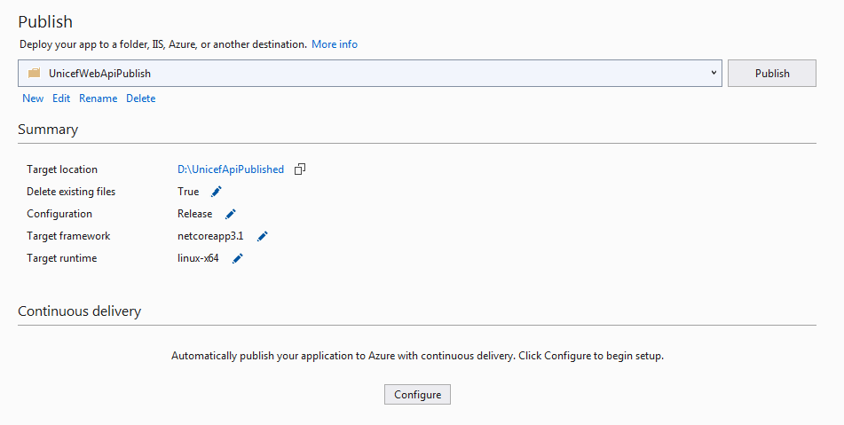

## Step 2 - Delete all at deploy folder Linux Server

Using Filzilla delete all files and folders from linux server location **/home/mosfiq/Deploy/Unicef/api.**

## Step 3 - Upload published output to Linux Server

Using Filezilla, upload published output to Linux server at location **/home/mosfiq/Deploy/Unicef/api.**

## Step 4 - Stop kestrel web application

Using MobaXterm, run following command:

**sudo systemctl stop kestrel-unicefapp.service**

## Step 5 - Delete deployed contents

Using MobaXterm, run following command:

**rm -r /var/www/unicefapp/\***

## Step 6 - Copy latest contents

Using MobaXterm, run following command:

**cp -R /home/mosfiq/Deploy/Unicef/api/* /var/www/unicefapp**

## Step 7 - Start web application

Using MobaXterm, run following command:

**sudo systemctl start kestrel-unicefapp.service**

## 